E_{u} Undrained Young’s modulus
ν_{u} Undrained Poisson ratio
K_{f} Fluid bulk modulus
n porosity
E drained Young’s modulus
ν drained Poisson ratio

From E_{u} and ν_{u} to E and ν:
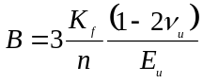 (intermediary result)
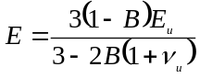
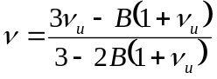

From E and ν to E_{u} and ν_{u}:
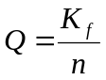, 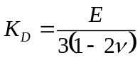, 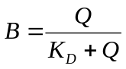 (intermediary result)
